Year 12 Human Biology
Reaction Time Validation Test

Name:
Teacher:

 | Marks Received | Marks Available | Percentage
Test |  | 35
Report |  | 5
Total |  | 40

Weighting 5%

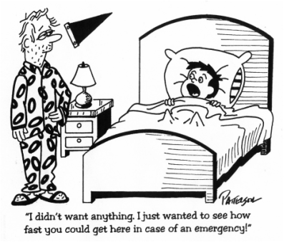

Use the report you have prepared on your investigation to answer questions 1 to 10.

1. What was your hypothesis?

Must have both variables (independent and dependant) and describe the predictied effect of the independent on the dependant.
(1 mark)

2. Identify the independent and dependant variables in this investigation

Dependant is Reaction Time
Independent varies

(2 marks)

3. What was the “Control Group” in your investigation?

The group before the independent variable was applied, or the group without the variable. (2 marks)

4. Identify three extraneous (uncontrolled) variables in either the method or equipment used in the investigation. Describe how you could control each variable.

One mark for correcting each of the uncontrolled variables. Each must be clearly stated.

(3 marks)
5. Do you think your hypothesis was supported:
a) by the overall data? Explain
No mark for yes or no. Evidence to support answer from the given data must be explained.

(1 mark)
b) by all individuals within the data? Explain.

No mark for yes or n. Evidence to support answer from the given data must be explained. (1 mark)

6. You were asked not to practise using the “Reaction Timer” before collecting data. How could this have affected your investigation?
Practising may have improved the ties of the trials. (1)
This would make the results invalid (1)
(2 marks)

7. To find out if your experiment was affected by the practise effect, plot your data for three
members of your group for their 5 trials for the “Before” or “Normal” situation on the grid
below (Hint. Trial number is on the horizontal axis).
(3 marks)


Key (1)
Title (1)
Axes (1)

8. Use evidence from your graph to decide if your data has been affected by the practise effect.

Correct conclusion
Evidence to support answer from the given data must be explained.
(2 marks)

9. What are the overall median and range of the data from all data displayed on the graph above?
Explain how you calculated each one.

Median is the central piece of data
Calculate it correctly
Range is the top result minus the bottom result
Calculate correctly
Lose one mark for not using units

(4 marks)

10. Discuss the reliability of your results.

Reliability means that the experiment is likely to yield the same results each time it is repeated.(1)

Our experiment was not reliable as we did not do enough trials – we only conducted x trials (1)

To ensure reliability we should have repeated the trials more than 20 times.

(3 marks)

Use the following information to answer question 11.

11. Below are the results of an investigation into braking response times under different conditions. Brown is a 22 year old, and Alterman is 37 years old. “Reading” is reading a text message on a mobile phone, “Texting” is typing the message that they had received and “Impaired” refers to a blood alcohol reading of above 0.08 percent.

Table 1: Reaction time averages at Table 2: Reaction time averages at
35 miles/hr 70 miles/hr
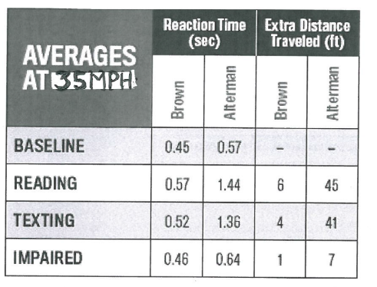
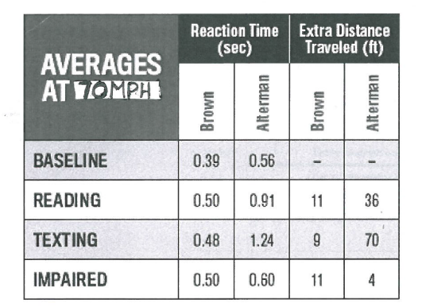

Graph 1: Worst reaction distances (feet)
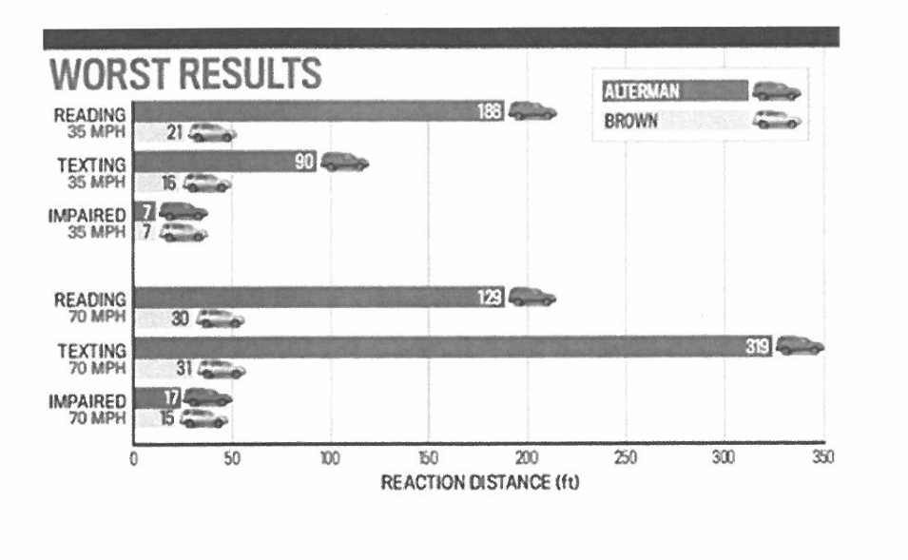

a) Give two possible hypotheses for this investigation.

Hypothesis 1: Reaction time slows with age.
Drink driving slows reaction time more/less than texting.
Texting while driving slows reaction time.
Any other valid hypothesis. Must have both variables and show the relationship between them.
Hypothesis 2: _______________________________________________________________
(2 marks)
b) Draw a conclusion for one of your hypotheses above. (indicate which hypothesis you have chosen) Justify your conclusion using evidence from the results.
Statement of conclusion relates to hypothesis. (1)
Describing in words data which supports hypothesis (1)
Use of numerical data to support conclusion. (1)
(3 marks)
c) In the results shown in Graph 1 there was an obvious outlier. Which result do you think this was? Why was this result considered to be an outlier? Make a prediction as to what this value should have been.
Outlier was Alterman texting at 70mph (1)
This was well outside the expected values (definition of outlier) (1)
For all other comparable results, the trend was that texting was always lower than reading. This one was not. Or similar explanation. (1)
Value should have been around 90ft (or 60ft) (1)
(4 marks)
d) A “risk assessment” is a process where the potential risks that may be involved in an investigation are evaluated and measures are taken to prevent harm to any participants.
Discuss two factors which would need to be considered in the Braking Response Time investigation and describe ways of minimising them.
Any risk/hazard (1) Method of minimising it (1)
Drivers running off the road.
Straight road.
Drivers hitting pedestrians/trees/objects.
Road with no objects/ clear verges.
Drivers being harmed in the event ofanaccident.
Wear seatbelts and helmets.
(2 marks)

